PSHE Subject Information

1. Purpose
Personal, Social, Health and Economic (PSHE) education supports pupils to develop the knowledge, skills and attitudes needed to lead safe, healthy and fulfilling lives.
The curriculum helps pupils understand themselves, develop positive relationships and navigate the wider world safely and responsibly. PSHE also plays an important role in supporting safeguarding and pupils’ wider personal development.
Relationships and Sex Education (RSE) is delivered in accordance with the school’s separate RSE Policy. This document outlines the school’s wider PSHE curriculum and how it contributes to safeguarding and personal development.

2. Statutory Context
PSHE supports the delivery of statutory Relationships Education and Health Education.
The school delivers Relationships and Sex Education in line with statutory guidance. Full details of how RSE is delivered can be found in the school’s separate RSE Policy.
This policy should therefore be read alongside the school’s RSE Policy.

3. Importance of PSHE in a SEND Setting
For many pupils with special educational needs and disabilities, explicit teaching of social understanding, safety, independence and relationships is particularly important.
The PSHE curriculum therefore focuses on the most important knowledge and practical strategies pupils need in order to stay safe, develop healthy relationships and prepare for adult life.
Learning is structured, revisited regularly and supported through clear examples, discussion and practical scenarios so pupils can apply learning in real-life situations.

4. Curriculum Structure
The PSHE curriculum is carefully sequenced so that knowledge and skills build progressively as pupils move through the school.
To ensure coherence and clarity, the curriculum is organised into six overarching strands which are revisited over time.

Life Beyond School
This strand focuses on preparing pupils for adulthood, further education, employment and independent living. Pupils explore careers, workplace expectations, financial awareness and independence.

Health and Well-being
This strand supports pupils to understand physical health, mental health and emotional wellbeing. Pupils learn about managing emotions, healthy lifestyles, resilience and seeking support.

Relationships
This strand focuses on developing positive and respectful relationships including friendships, family relationships, communication and boundaries. RSE is delivered through this strand.

Staying Safe On and Offline
This strand helps pupils recognise risks and develop strategies to keep themselves safe both in the real world and online. Topics include online safety, recognising exploitation and managing peer pressure.

Celebrating Diversity and Equality
This strand supports pupils to understand and respect diversity, challenge discrimination and recognise the importance of equality and inclusion.

Rights, Responsibilities and British Values
This strand supports pupils to understand their role within society including laws, rights, responsibilities, democracy and respect for others.

5. Contextual Safeguarding Curriculum
Safeguarding risks affecting young people can change throughout the academic year. The school therefore includes a flexible contextual safeguarding block within the PSHE programme.
This allows additional safeguarding lessons to be delivered when concerns arise that affect the pupil cohort or the local community.
Topics may include:
• group chats and social media behaviour
• online harassment or bullying
• sharing images online
• peer pressure within friendship groups
• emerging online risks
• safeguarding concerns identified within the local area
The timing of this block is intentionally flexible so lessons can be delivered when they are most needed.

6. PSHE and Personal Development
PSHE plays a central role in supporting pupils’ wider personal development.
Through the curriculum pupils develop:
• knowledge needed to keep themselves safe
• skills to manage relationships and social situations
• confidence to seek help when needed
• understanding of rights and responsibilities
• the ability to make informed decisions
PSHE complements wider pastoral support, behaviour systems and safeguarding processes within the school.

7. Safeguarding Through the Curriculum
PSHE contributes significantly to the school’s safeguarding responsibilities.
Through the curriculum pupils learn to recognise risks, understand personal boundaries and know how to seek help if they are worried about themselves or others.
Key safeguarding topics include:
• online safety and digital behaviour
• recognising exploitation and grooming
• bullying and harassment
• peer pressure and risky behaviour
• substance misuse
• personal safety in public spaces

8. SMSC Development
The PSHE curriculum contributes to pupils’ spiritual, moral, social and cultural development.
Spiritual development is supported through opportunities to reflect on values and personal experiences.
Moral development is supported through discussions about fairness, responsibility and ethical decision-making.
Social development is supported through collaboration, communication and developing positive relationships.
Cultural development is supported through understanding diversity and life in modern Britain.

9. British Values
The curriculum supports pupils to understand the fundamental British values of:
• democracy
• the rule of law
• individual liberty
• mutual respect
• tolerance of different faiths and beliefs
Pupils explore how these values apply in their everyday lives and within wider society.

10. Embedding British Values, SMSC and Protected Characteristics in Teaching

British Values (BV), SMSC and Protected Characteristics (PC) are embedded within the PSHE curriculum and are identified within lesson planning where they are most relevant and meaningful.

Teachers are expected to make these links explicit during teaching and should not assume that pupils will automatically recognise the connections themselves.

Examples of these links are shown within the curriculum planning documents. These demonstrate where key concepts such as democracy, equality, respect, tolerance and rights are taught through specific lessons and topics.
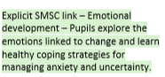
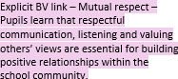
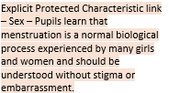

To support consistency, reference posters for British Values, SMSC and Protected Characteristics are included within teacher books. These act as a prompt for staff and support pupils in revisiting and remembering these ideas over time.
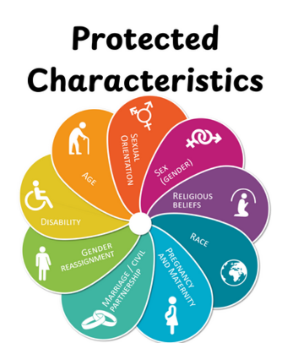
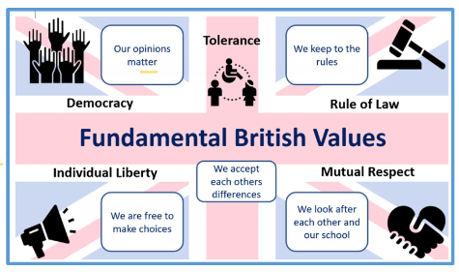
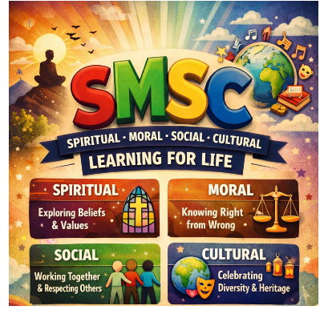

British Values, SMSC and Protected Characteristics may also form part of retrieval and review activities where appropriate. This helps reinforce understanding and supports pupils in remembering and applying these ideas over the longer term.10. Meeting the Needs of Pupils with SEND

11. Meeting the needs of pupils with SEND
Teaching is adapted to ensure pupils with SEND can access and benefit from the PSHE curriculum.
Approaches may include:
• clear and simplified explanations
• repetition and revisiting key ideas
• real-life examples and scenarios
• visual supports
• breaking complex topics into manageable steps
Lessons are delivered sensitively and staff follow safeguarding procedures if concerns arise.

12. Monitoring
The PSHE curriculum is monitored by leaders responsible for personal development.
Monitoring may include:
• review of curriculum planning
• learning walks
• pupil voice
• review of safeguarding and behaviour data
This ensures the curriculum remains relevant and responsive to the needs of pupils.

